Assignement 2 Report Prabhat Kumar(MT17036)
1st Dataset

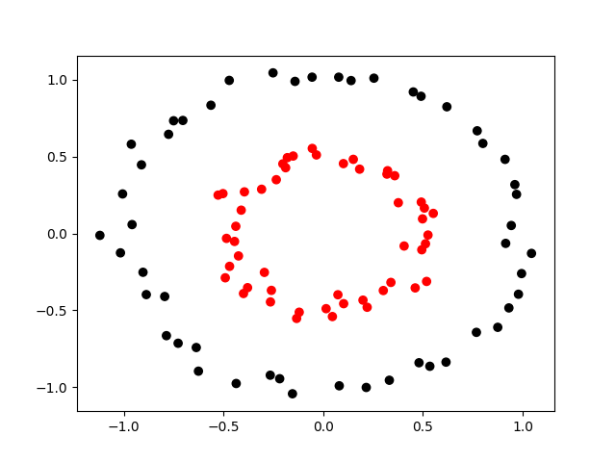
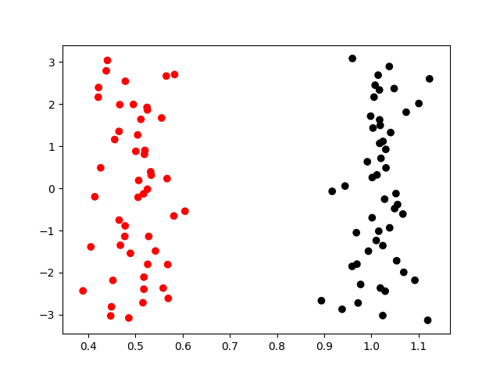
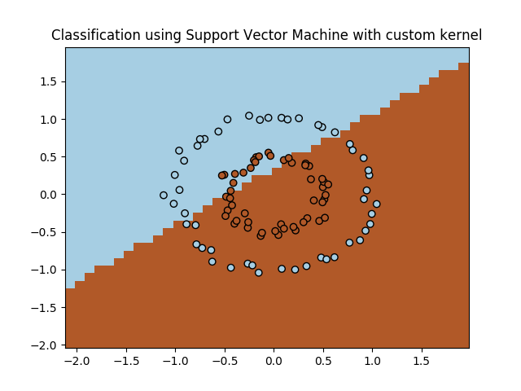
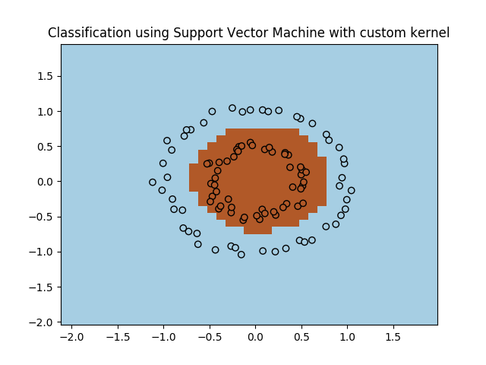
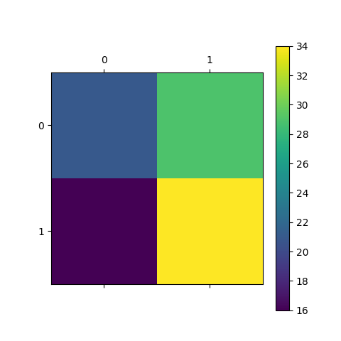
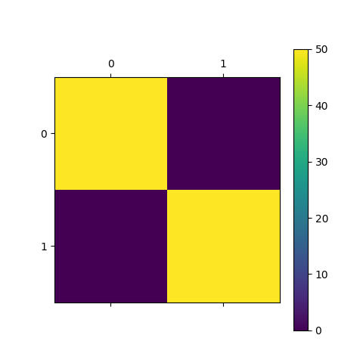

Confusion Matrix For Linear Kernel Confusion Matrix for RBF Kernel
- This dataset can be made linearly seperable by converting into polar co-ordinates.
- Classes can’t be seperated using Linear Kernel
- Dataset can be seperated using RBF Kernel
- No need for Outlier Removal

2nd Dataset

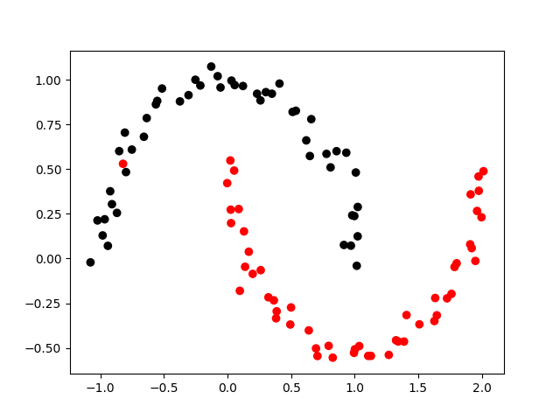
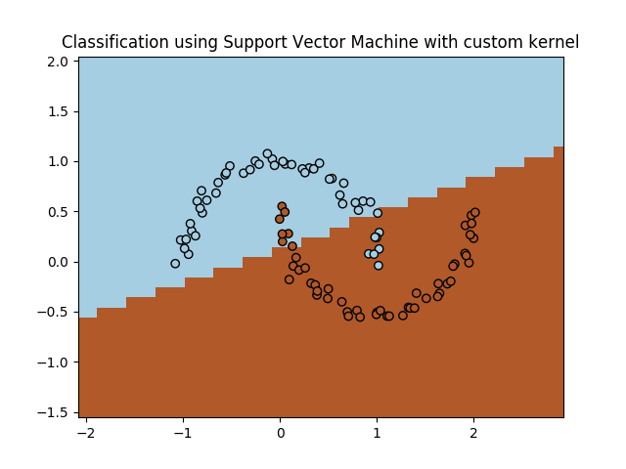
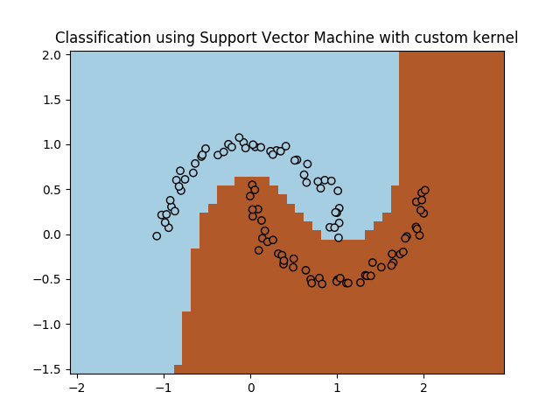
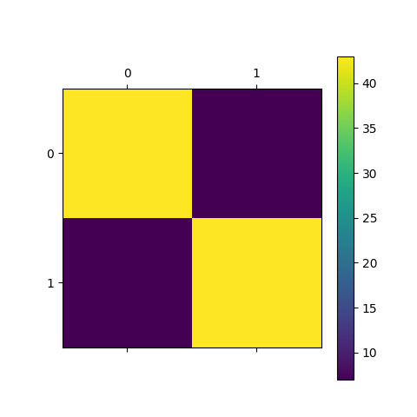

Confusion Matrix for Linear(above) and RBF Kernel(Left)

- This dataset visualises the standard moon shaped graph
- These are cant be seperated by Linear Kernel but can be easily seperated by RBF kernel with 100% accuracy at Gamma=1
- Outlier Removal not needed

Dataset 3
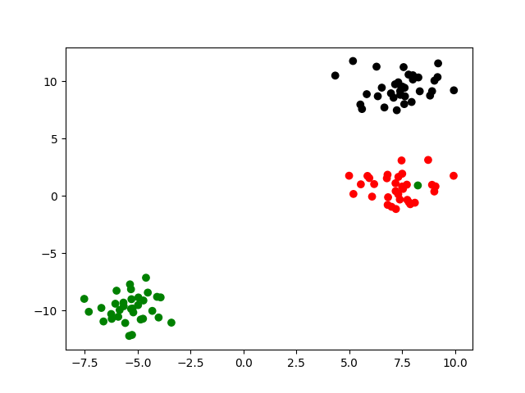
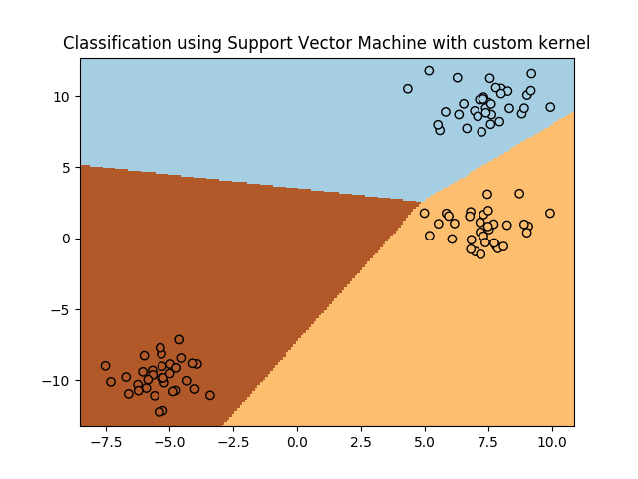
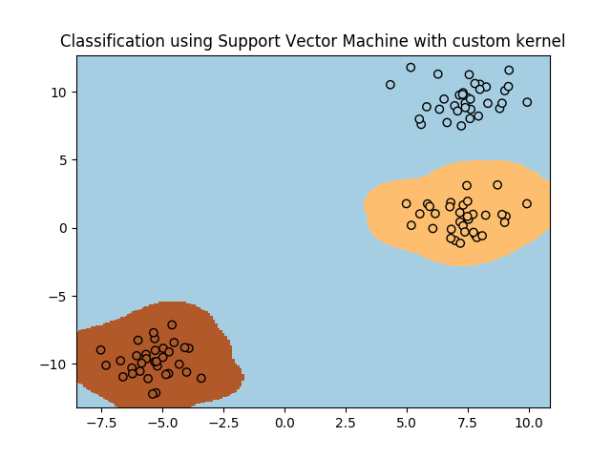
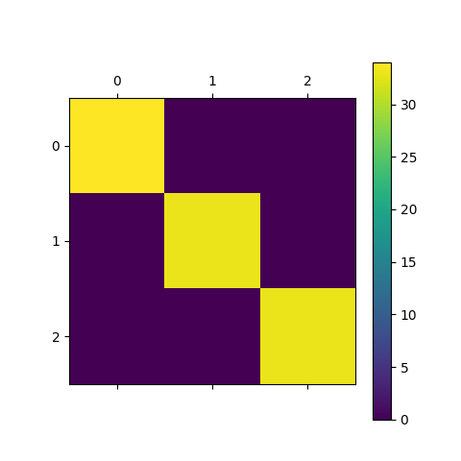

- Dataset contains 3 classes
- Dataset is linearly seperable giving 100% accuracy wiith C=1 as default
- Dataset also gives 100% accuracy with RBF kernel with Gamma’s default value =1
- As both RBF and Linear give 100% accuracy over the data, they have similar confusion matrix

Dataset 4
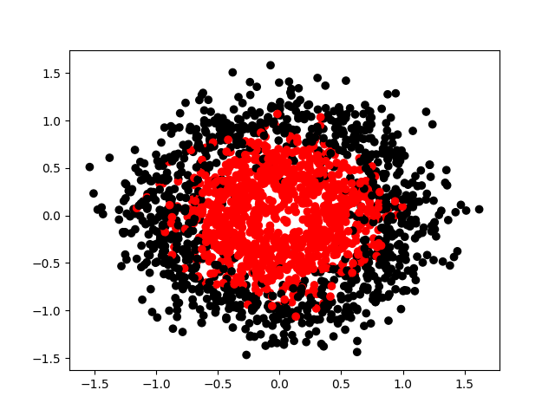
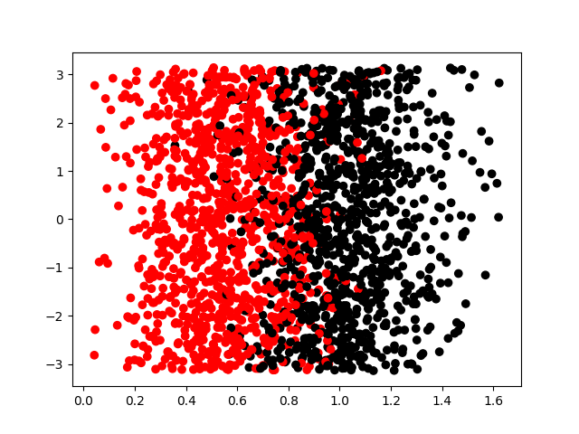

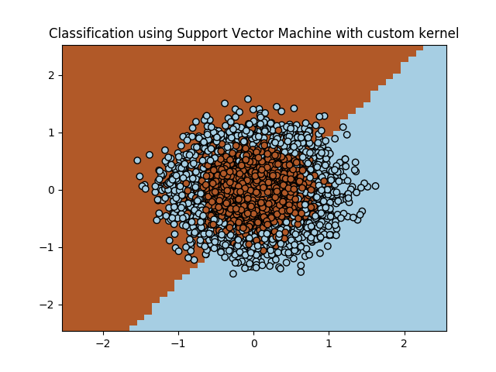
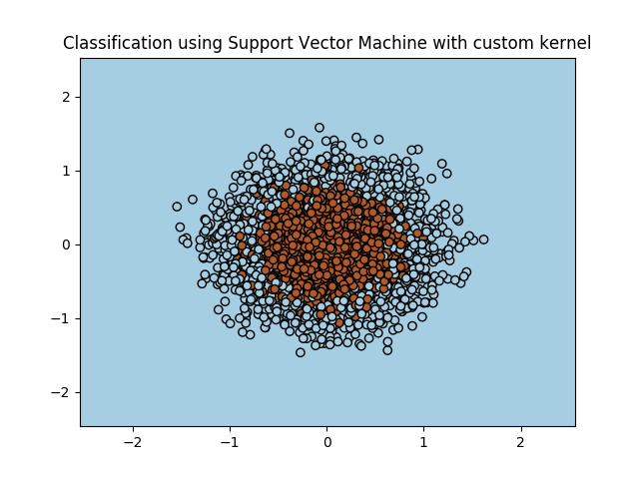
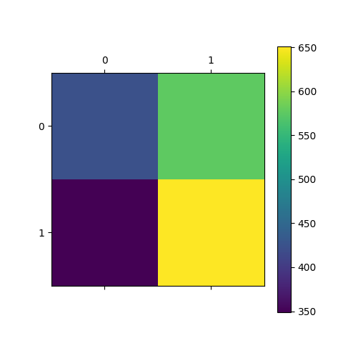
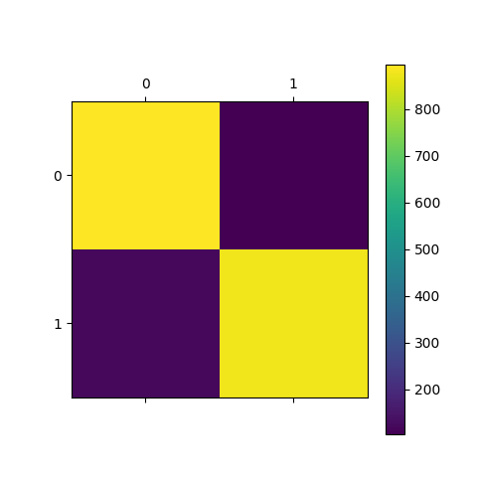

Confusion Matrix for Linear(left) and RBF(right) kernel
- Extension of Dataset 1 with noise
- Can be seperated with linear transformation after using Outlier removal techniques
- Can also be seperated using RBF Kernel after using Outlier removal techniques
Dataset 5
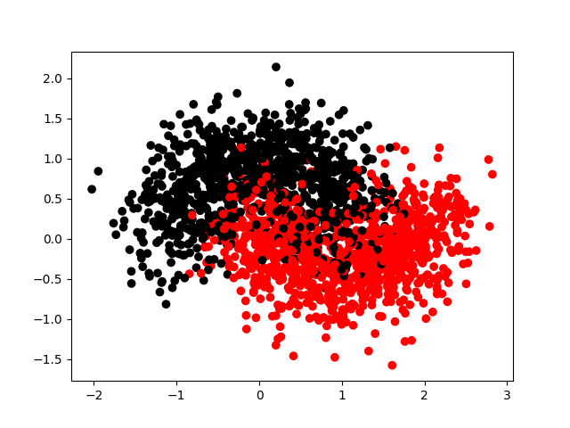
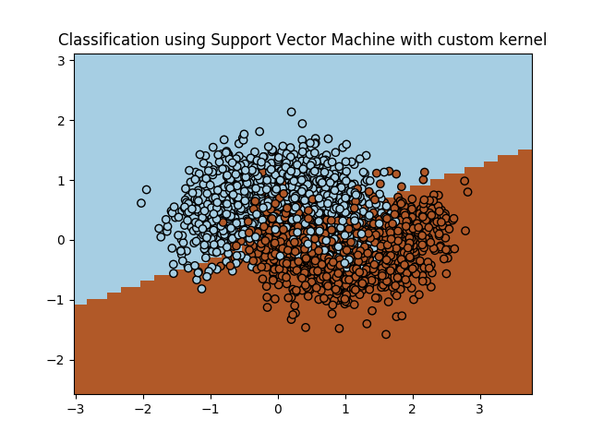
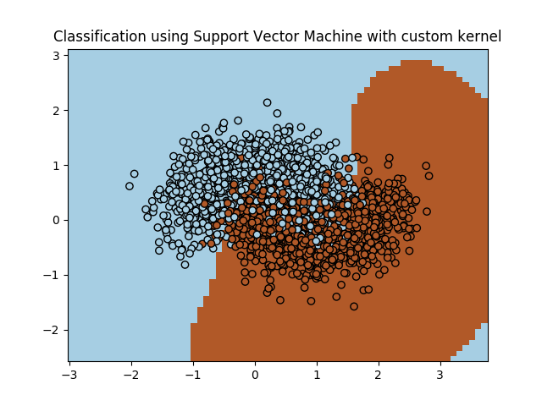
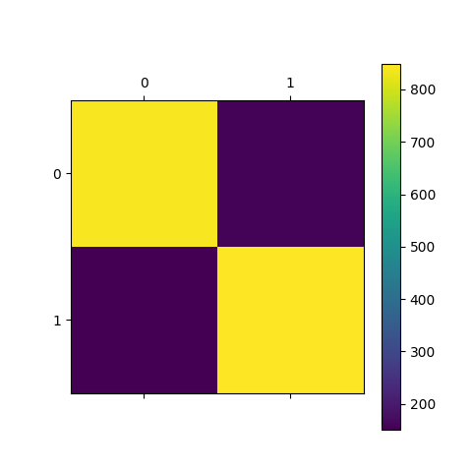

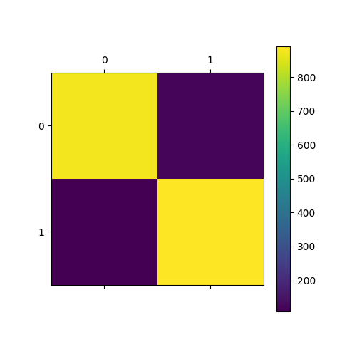

Confusion Matrix for Linear(above) and RBF(left) Kernel

- Dataset is an extension of Dataset 2
- Data cannot be made completly linearly seperable due to present on noise
- Data can be made linearly seperable after using Outlier Removal techniques.

Kaggle Competition

Data Given:
Movie Review Data was given in form of numbers where words were mapped to numbers
Preprocessing :
As Data was initially was a review, the data therefore was converted into orginal strings just like reviews were, with numbers inplace of words.
Redundant data was removed ie data with same datapoints and targets
Feature extraction on the basis occurance of numbers in the string was done using Count Vectorizer from Sklearn Library
Feature Extraction was tried for both unigram and bigram

Models Used :
LinearSVM was used with hyperparameter C in range[0.1,3]
Rbf kernel used with default Gamma =1
Polynomial SVM was used with degree =2,3
Best MAE was accomplished using LinearSVM with C=0.1

Source Code : kaggle.py

Reference:
Contour Plotting was refered from Sklearn User Guide
Preprocessing Data idea was discussed with Vaibhav Varshney

